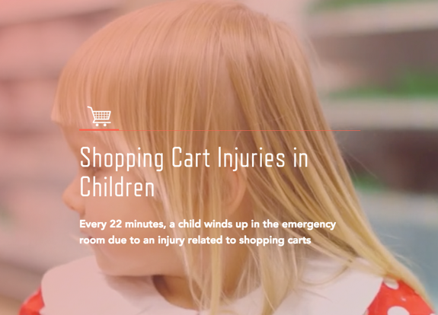

From 1990 to 2011, it is estimated that 530,494 children under the age of 15 found themselves in the hospital for shopping cart related accidents. While voluntary shopping cart safety standards were introduced in 2004, aiming to reduce the high volume of these injuries, we continually see the shopping cart injury rate climb. So how do we address this issue and improve shopping cart safety for children?

How Are Shopping Cart Injuries Happening?
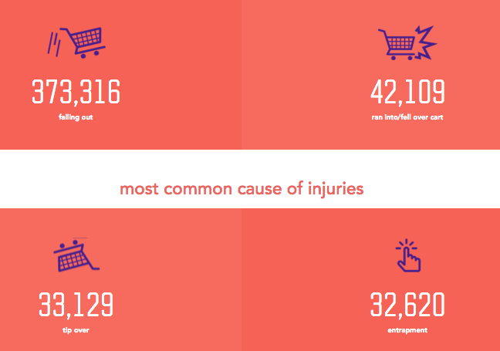
According to the shopping cart injury guide published by Rosenbaum & Associates, the top four causes of these injuries are:
- Children falling out of the cart
- Children running into or falling over a cart
- The cart tipping over
- Cart entrapment
Head injuries prove to be the most common type of injuries when shopping cart accidents occur, which can be especially dangerous for a child’s developing brain. In fact, one report concluded that 79% of head injuries were among children under the age of 5.

How can we take action and improve children’s safety while shopping? Here are nine essential safety tips to remember the next time you are out shopping with your child:

Essential Shopping Cart Safety Tips
- Whenever possible, find alternatives to placing your child in a shopping cart
- Proper usage is extremely important. Always use shopping cart safety straps, and make sure your child is snugly secured in the straps. Children’s legs should be placed through the leg openings
- If parts of the cart restraint system are missing or are not working, choose a different cart
- Make sure your child remains seated. Never allow him/her to stand on the seat or in the basket of a cart
- Stay with the shopping cart and your child at all times
- If you use a cart that has a child safety seat in it, use one that is low to the ground
- Avoid placing infant car seats or any other carriers on top of shopping carts
- Never permit a child to push other children in the cart
- Avoid allowing your child to stand on the front, side or back of the cart. Arms legs or articles of clothing can become pinched or caught

Sources
For more information on shopping cart accidents, check out the Rosenbaum & Associates Shopping Cart Injury Guide at http://www.rosenbauminjuryfirm.com/shopping-cart-injuries/

